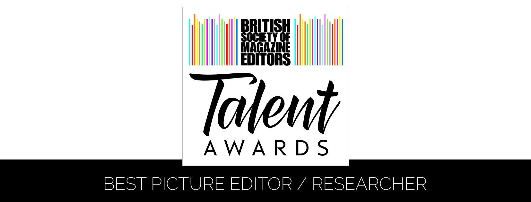

Entry Form – Best Picture Editor / Researcher
Name of Line Manager:
Name of Picture Editor/Researcher:
Name of Editor:
Magazine/website:
Publishing company:
Address:
Email:
Telephone:
Details of work enclosed:
Example of work: |  | Publication date:
Number of staff on the title:
Please tick as appropriate: | 1. I (line manager) was a member of the BSME during the period 1 January to 31 December 2016 and an entry fee of £95.00 is enclosed/I have paid online
 | 2. I (line manager) was NOT a member of the BSME during the period 1 January to 31 December 2016 and an entry fee of £118.00 is enclosed/I have paid online
Name & signature of art director:
Name & signature of editor:

For queries or further information, please contact:

BSME Administration, Gill Branston & Associates. Tel: 020 8906 4664, Email: admin@bsme.com

