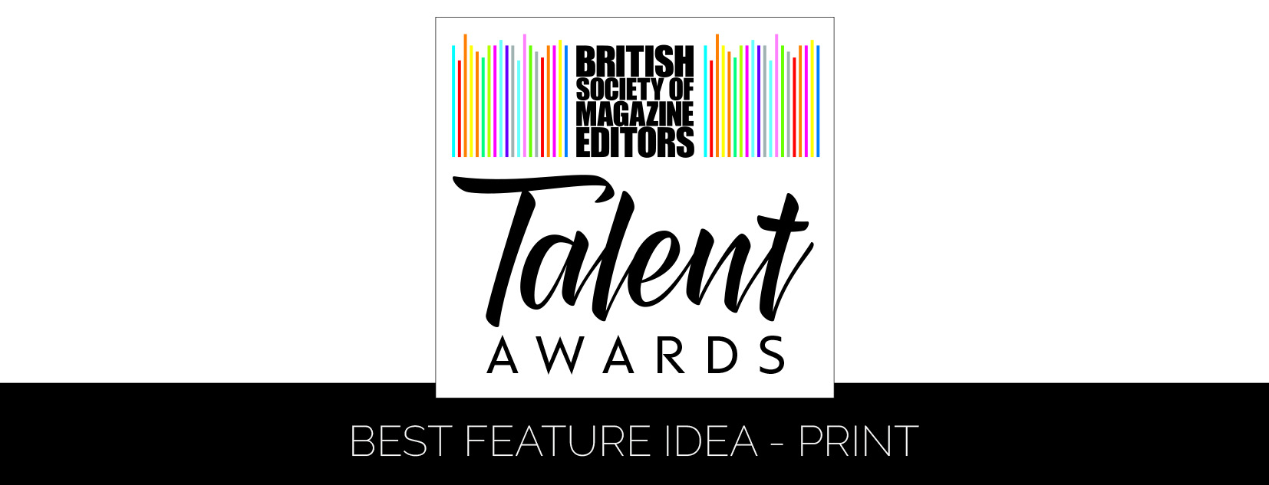

Entry form – Best Feature Idea – Print
Name of line manager responsible for entry:
Name and job title/s of nominee/s (please put ‘(F)’ if freelance):

Please note that the Editor / Editorial Director may not be included as an entrant as they are eligible to enter the main BSME Awards
Contact person:
Name of editor:
Magazine:
Publishing company:
Address:
Email:
Telephone:
Feature Details:
Name of feature: |  | Publication date:
Number of staff on the title:
Please tick as appropriate: | 1. I (line manager) was a member of the BSME during the period 1 January to 31 December 2017 and an entry fee of £100.00 is enclosed/I have paid online
 | 2. I (line manager) was NOT a member of the BSME during the period 1 January to 31 December 2017 and an entry fee of £125.00 is enclosed/I have paid online
Name & signature of feature editor:
Name & signature/s of nominee/s:
Name & signature of editor:

For queries or further information, please contact:

BSME Administration, Gill Branston & Associates. Tel: 020 8906 4664, Email: admin@bsme.com

