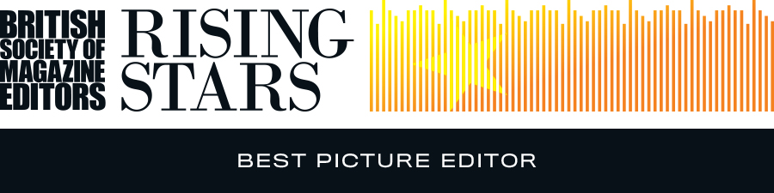

Entry Form – Best Picture Editor
Name of art director:
Name of Picture Editor:
Name of editor:
Magazine/website:
Publishing company:
Address:
Email:
Telephone:
Details of work enclosed:
Example of work: |  | Publication date:
Number of staff on the title:
Please tick as appropriate: | 1. I (art director) was a member of the BSME during the period 1 January to 31 December 2015 and an entry fee of £75.00 is enclosed/I have paid online
 | 2. I (art director) was NOT a member of the BSME during the period 1 January to 31 December 2015 and an entry fee of £98.00 is enclosed/I have paid online
Name & signature of art director:
Name & signature of editor:

For queries or further information, please contact:

BSME Administration, Gill Branston & Associates. Tel: 020 8906 4664, Email: admin@bsme.com

