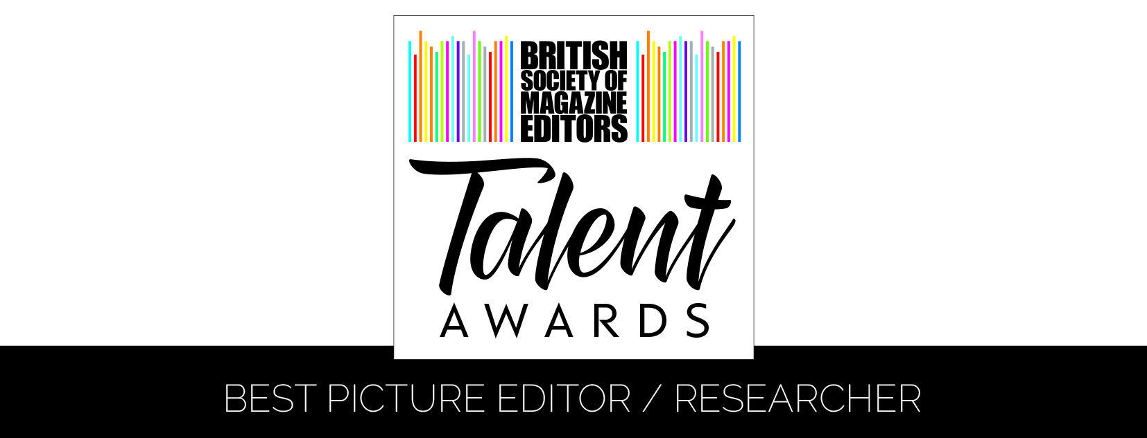
Entry Form – Best Picture Editor / Researcher
Name of Line Manager:
Name of Picture Editor/Researcher:
Name of Editor:
Magazine/website:
Publishing company:
Address:
Email:
Telephone:
Details of work enclosed:
Example of work: |  | Publication date:
Example of work: |  | Publication date:
Example of work: |  | Publication date:
Number of staff on the title:
Please tick as appropriate: | 1. I (line manager) was a member of the BSME during the period 1 January to 31 December 2018 and an entry fee of £95.00 + VAT (£114.00) enclosed/I have paid online
 | 2. I (line manager) was NOT a member of the BSME during the period 1 January to 31 December 2018 and an entry fee of £120.00 + VAT (£144.00) is enclosed/I have paid online
Name & signature of Line Manager:
Name & Signature of Picture Editor/Researcher
Name & signature of Editor:
CHECKLIST  Enclosed are: | - USB containing::  - Entry Form (Word document including any digital links)  - PDF Containing:  Supporting Statement  3 x pieces of work  - 1 x print-out of :  - Entry Form  - Supporting Statement  - 3 x pieces of work  - Payment – if not made online

For queries or further information, please contact:

BSME Administration, Gill Branston & Associates. Tel: 020 8906 4664, Email: admin@bsme.com

