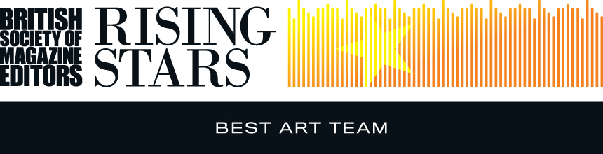

Entry form – Best Art Team
Name and job title of art department head responsible for submitting entry:
Names of individual members (please put ‘(F)’ if freelance:
Contact person:
Name of editor:
Magazine:
Publishing company:
Address:
Email:
Telephone:
Details of work enclosed:
1. Example of work: |  | Publication date:
2. Example of work: |  | Publication date:
3. Example of work: |  | Publication date:
Number of staff on the title:
Total number of staff on the art team (including freelance):
Number of freelance staff on the art team:
Please tick as appropriate: | 1. I (art department head) was a member of the BSME during the period 1 January to 31 December 2015 and an entry fee of £75.00 is enclosed/I have paid online
 | 2. I (art department head) was NOT a member of the BSME during the period 1 January to 31 December 2015 and an entry fee of £98.00 is enclosed/I have paid online
Name & signature of art department head:
Name & signature of editor:

For queries or further information, please contact:

BSME Administration, Gill Branston & Associates. Tel: 020 8906 4664, Email: admin@bsme.com

